CS 3100

Xuan Pham

Emily McMahon & John Rees

December 9, 2019

# Reports from SQL

1. Student Table

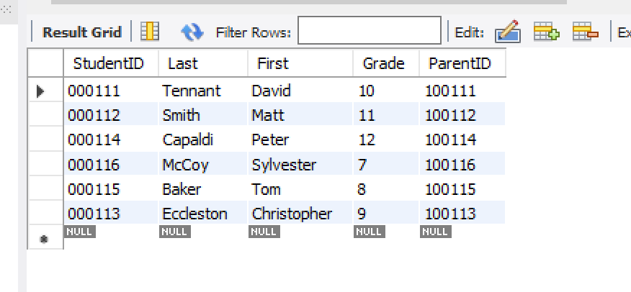

1. Meal Status Table

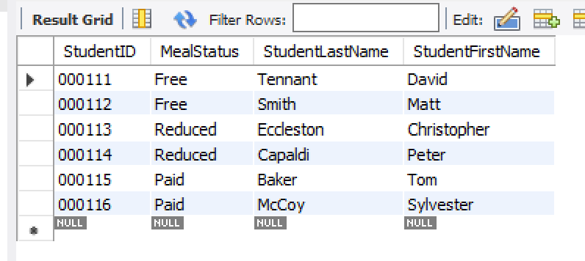

1. Parents Table

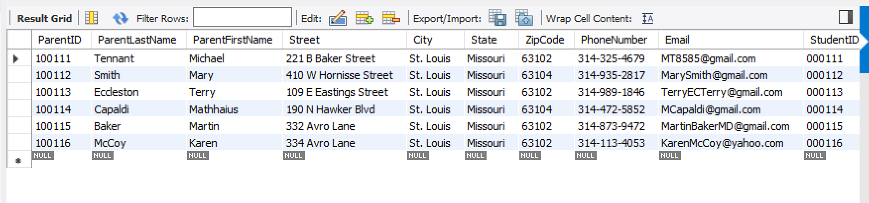

1. Meals Table

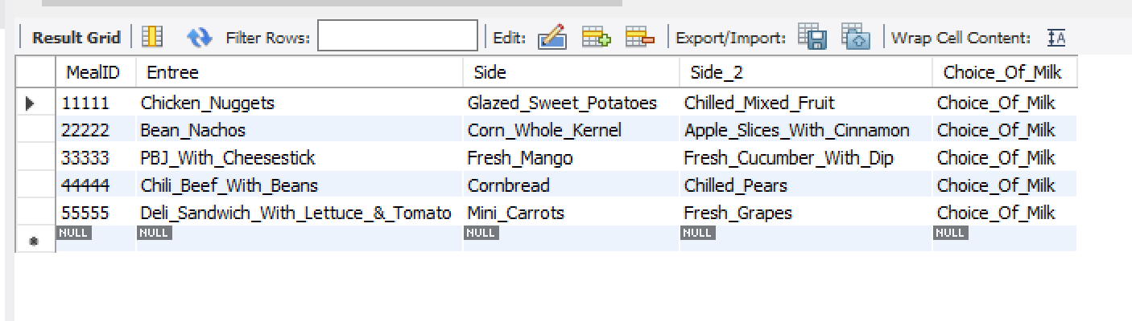

1. Daily Transactions

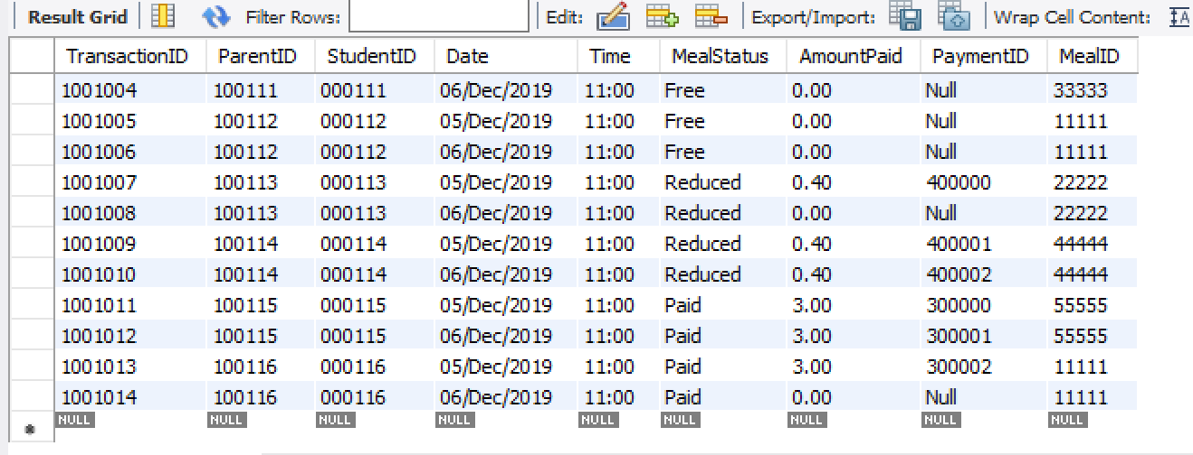

1. Daily Transactions by Day and Cost

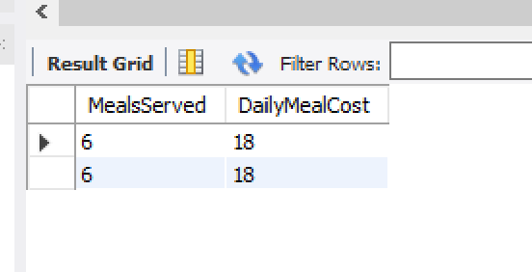

1. Total Free Meals

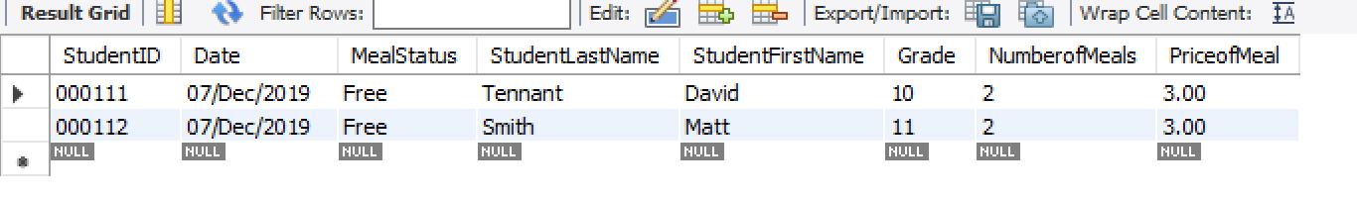

1. Free Meals w/ Reimbursements

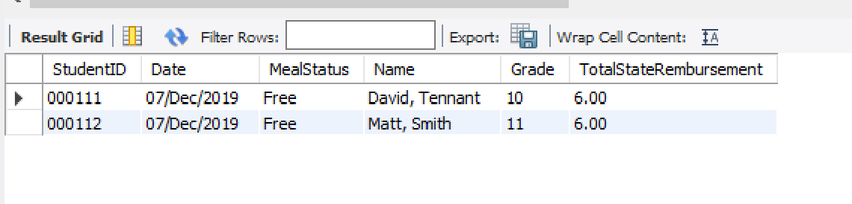

1. Total Reduced Meals

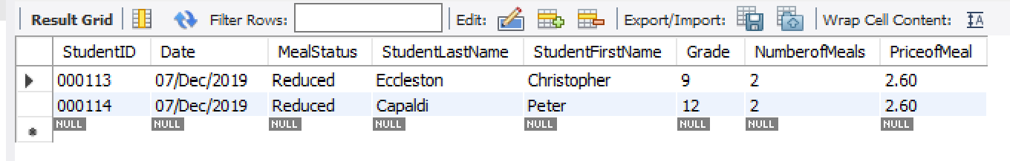

1. Reduced Meals w/ Reimbursement

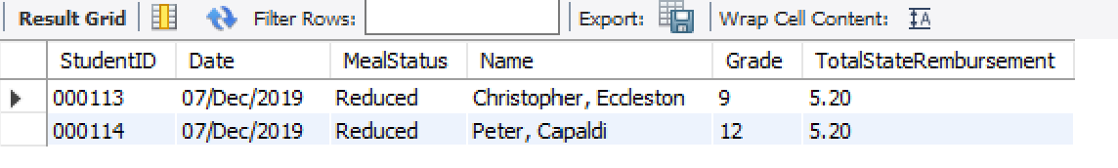

1. Payments

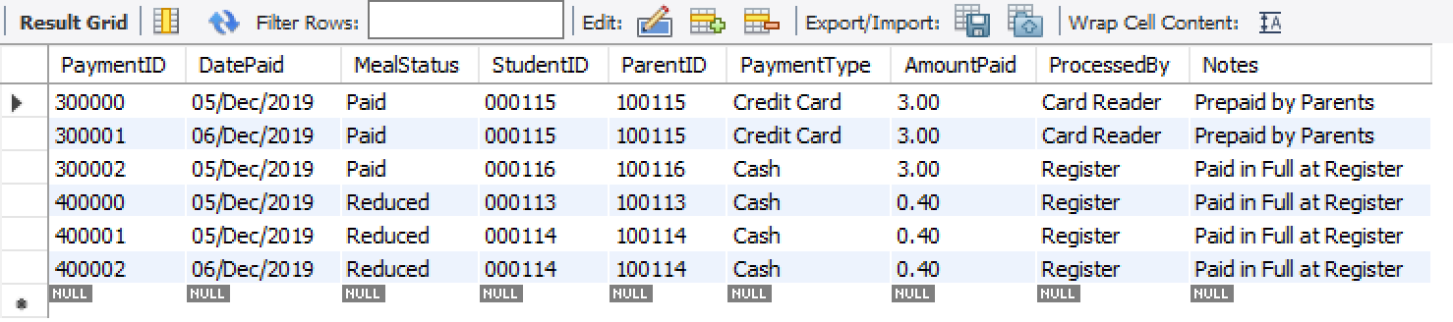

1. Balances

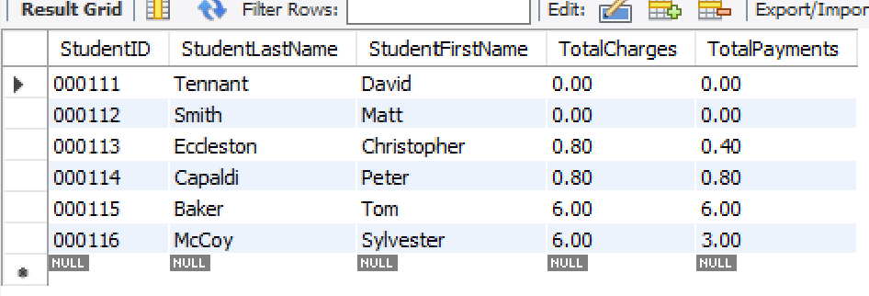

1. Balances Students Owe

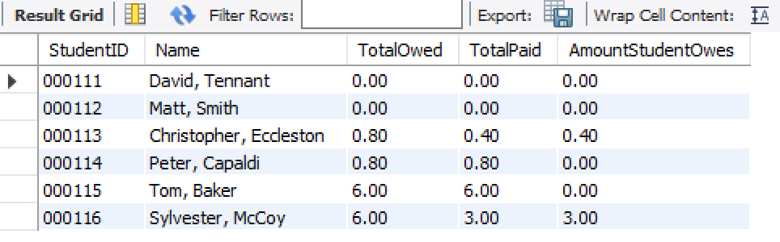

**Procedure for Getting Student’s Parent Information**

DELIMITER $$

CREATE PROCEDURE StudentParentContacts (StudNum INT)

BEGIN

SELECT

s.StudentID,

CONCAT(s.StudentLastName, ', ', s.StudentFirstName) AS 'StudentName',

s.Grade,

p.ParentID,

CONCAT(p.ParentLastName, ', ', p.ParentFirstName) AS 'ParentName',

p.PhoneNumber AS 'ContactNumber'

FROM Students s

INNER JOIN Parents p

ON s.ParentID = p.ParentID

WHERE s.StudentID = StudNum;

END$$

DELIMITER ;

CALL StudentParentContacts(000111);

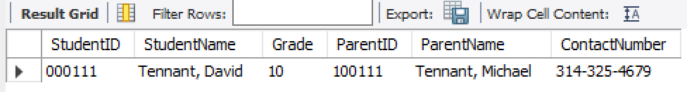

**Procedure for Getting Student Balances**

DELIMITER $$

CREATE PROCEDURE StudentBalances (StudNum INT)

BEGIN

SELECT

s.StudentID,

CONCAT(s.StudentLastName, ', ', s.StudentFirstName) AS 'StudentName',

s.Grade,

s.ParentID,

b.TotalCharges AS 'TotalOwed',

b.TotalPayments AS 'TotalPaid',

SUM(b.TotalCharges - b.TotalPayments) AS 'AmountStudentOwes'

FROM Students s

INNER JOIN Balances b

ON s.StudentID = b.StudentID

WHERE b.StudentID = StudNum;

END$$

DELIMITER ;

CALL StudentBalances(000114);

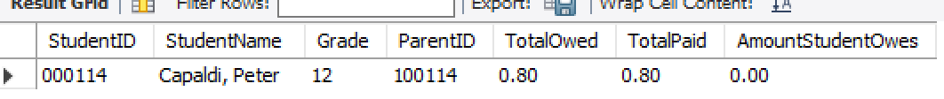

**Procedure for Student Payments**

DELIMITER $$

CREATE PROCEDURE StudentPayments (StudNum INT)

BEGIN

SELECT

s.StudentID,

CONCAT(s.StudentLastName, ', ', s.StudentFirstName) AS 'StudentName',

p.PaymentID,

p.DatePaid,

p.PaymentType,

p.AmountPaid,

p.ProcessedBy,

p.Notes,

p.ParentID

FROM Students s

INNER JOIN Payments p

ON s.StudentID = p.StudentID

WHERE s.StudentID = StudNum;

END$$

DELIMITER ;

CALL StudentPayments(000114);



**Procedures for Reimbursements for Free Students**

DELIMITER $$

CREATE PROCEDURE RembursementsFree (StudNum INT)

BEGIN

SELECT

StudentID,

CONCAT(StudentLastName, ', ', StudentFirstName) AS 'StudentName',

Grade,

SUM(NumberofMeals * PriceofMeal) AS 'TotalStateRembursement'

FROM TotalFreeMeals

WHERE StudentID = StudNum;

END$$

DELIMITER ;

CALL RembursementsFree(000112);

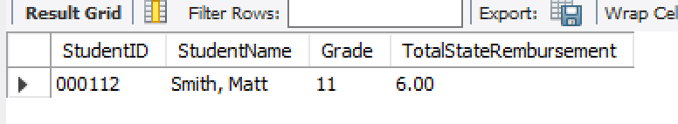

**Procedures for Reimbursements for Reduced Students**

DELIMITER $$

CREATE PROCEDURE RembursementsReduced (StudNum INT)

BEGIN

SELECT

StudentID,

CONCAT(StudentLastName, ', ', StudentFirstName) AS 'StudentName',

Grade,

SUM(NumberofMeals * PriceofMeal) AS 'TotalStateRembursement'

FROM TotalReducedMeals

WHERE StudentID = StudNum;

END$$

DELIMITER ;

CALL RembursementsReduced(000113);

